**Lesson05 Azure Service Logs**

**Notes: -**

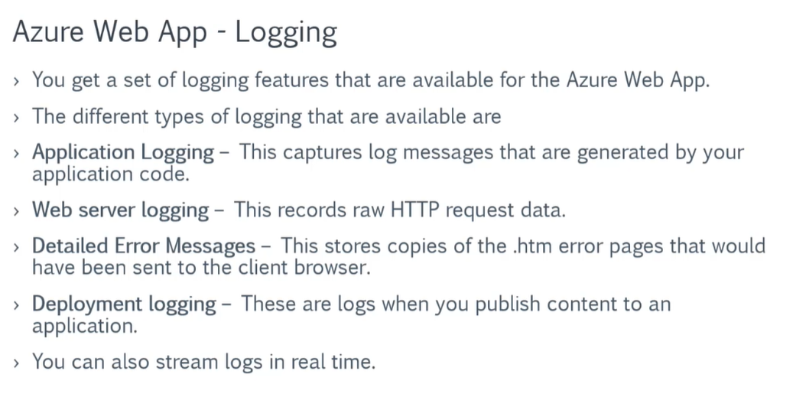

**1-on Azure App Service > Monitoring > App service logs**

**(You will see that you can enable the type of logging you want and the logging type)**

**2-you can set the Quota of logging type and the retention period that hold the logs**

**(You can access to logs through FTP of FTPS)**

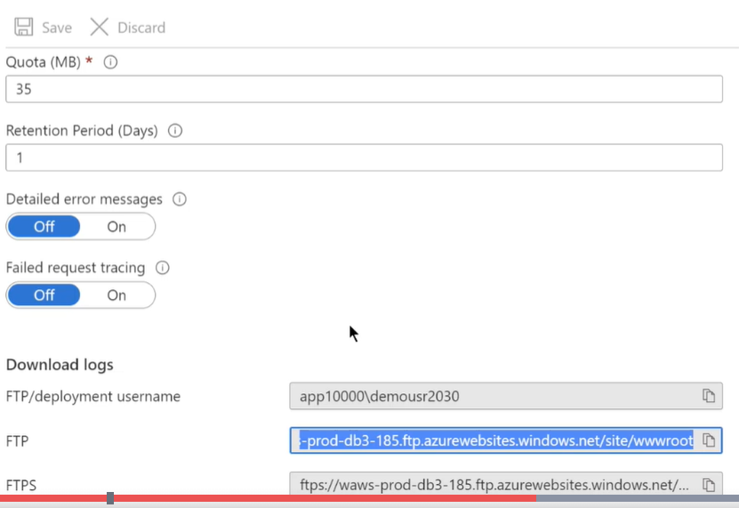

**3-if you want to see logs on the dashboard go to the monitoring > log stream**

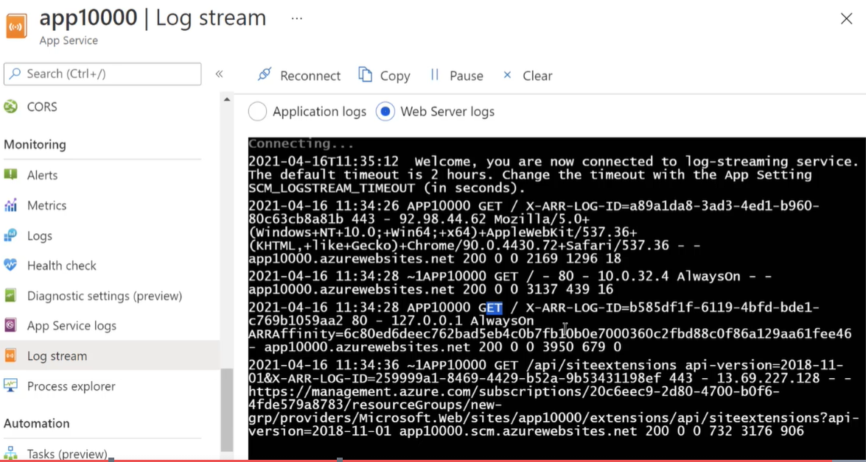

**Section02 Deployment**

**Notes: -**

**1-on VS 2019 create new project called SampleWebApp and on Git repository create new repository and push your changes on that repository.**

**2-on Azure > Web App server > create > continuous deployment**

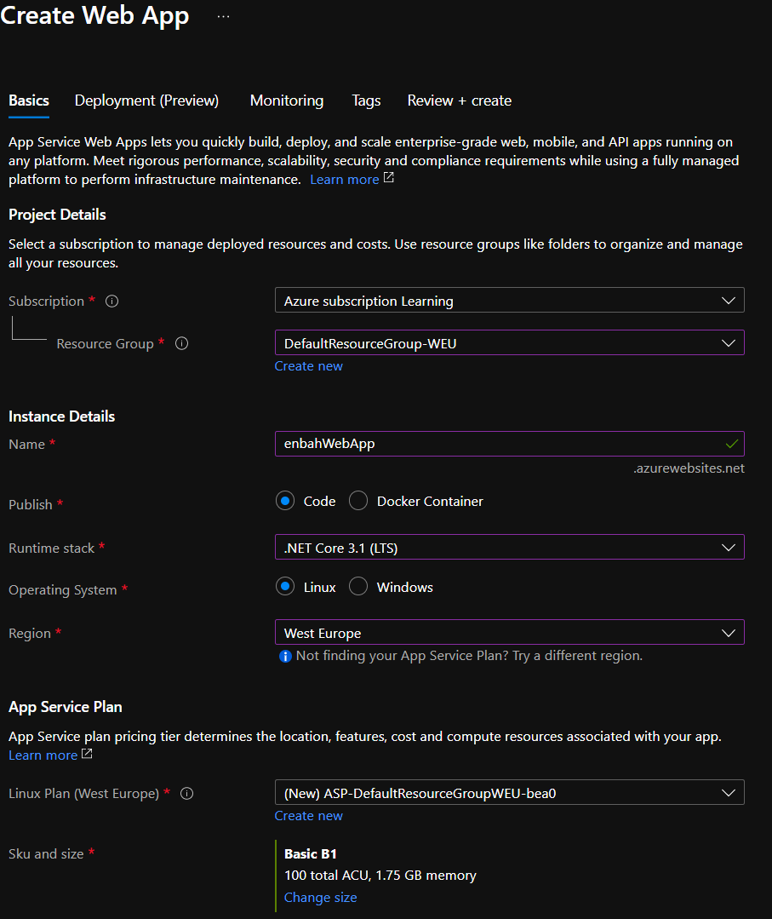

**2-on Deployment (Preview) we choose the account with select repository and branch**

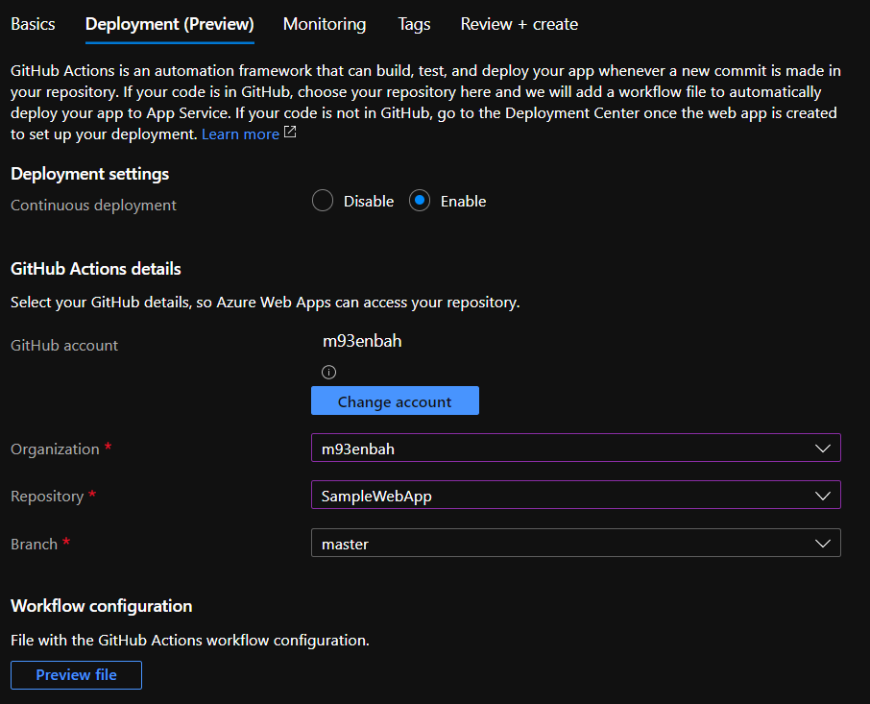

**(We can apply Sync to ensure that any push to the repository it will reflect to Azure web app service)**

**(Its take couple of minutes to reflect the changes from the GitHub repository to the Azure App Service)**